Heritage Treasures: An In-Depth Analysis of UNESCO World Heritage Sites in Tableau
Final Project Report

Date | 22 July 2026
Team ID | TEAM-HT-2026
Team Lead | Devendra Reddy
Team Member | DHARA MAHITHA

1. Introduction
1.1 Project Overview
Heritage Treasures is a Tableau-based data visualization project built on the UNESCO World Heritage Sites (2019) dataset. It brings together country-level distribution, danger/risk status, and regional inscription trends into a single interactive dashboard and guided story, which is published to Tableau Server/Public and embedded into a Flask web application for easy stakeholder access.
1.2 Purpose
The purpose of this project is to help heritage conservation analysts, government policy makers, tourism boards, and cultural researchers quickly understand which countries hold the most heritage sites, which sites are most at risk, and how conservation/inscription efforts have trended across regions over time — without manually sifting through raw spreadsheet data.
2. Ideation Phase
2.1 Problem Statement
PS | I am (Customer) | I'm trying to | But | Because | Which makes me feel
PS-1 | a Heritage Conservation Analyst / Policy Maker | identify which countries/regions have the most sites and the highest concentration of at-risk sites | the raw UNESCO dataset is large and unstructured across many attributes | there is no single easy-to-read view of at-risk sites | overwhelmed and unable to prioritize conservation funding
PS-2 | a Tourism Board Official / Cultural Researcher | understand how heritage inscriptions have trended over time across regions | inscription dates and regional groupings are buried in raw rows | manually tracking growth patterns year over year is slow and error-prone | unable to confidently identify which regions are increasing conservation efforts
2.2 Empathy Map Canvas
Persona: Heritage Conservation Analyst / Government Policy Maker
Quadrant | Key Points
Says | “I need to know which countries have the most heritage sites at a glance.” / “I want to see inscription changes by region.”
Thinks | There must be a faster way to compare countries than scrolling through rows.
Does | Downloads the raw CSV and manually filters/counts rows in a spreadsheet.
Feels | Frustrated by manual effort; relieved once a clear visual shows the pattern.
Pains | Data is large and unstructured; no easy way to see year-over-year trends by region.
Gains | An interactive dashboard with country counts, danger split, and a guided story.
2.3 Brainstorming
Ideas were grouped and prioritized as follows:
Idea | Impact | Feasibility | Priority
Treemap of sites by country | High | High | 1 – Must Have
Pie chart of sites in danger | High | High | 1 – Must Have
Line chart of regional inscription trends | High | Medium | 1 – Must Have
Interactive filter panel (Region/Category/Year) | Medium | High | 2 – Should Have
Multi-scene guided story | Medium | Medium | 2 – Should Have
Flask web app embedding | High | Medium | 2 – Should Have
3. Requirement Analysis
3.1 Customer Journey Map
Stakeholders move through five stages when using the dashboard: becoming aware of the published dashboard/story link (Entice), opening it and getting oriented (Enter), exploring the treemap, pie chart, trend line and filters (Engage), drawing conclusions and sharing findings (Exit), and returning later as new data is published (Extend). Positive moments center on fast, clear insight; the main friction point is the initial load time of the embedded Tableau view.
3.2 Solution Requirement
Functional Requirements
ID | Requirement | Details
FR-1 | Data Collection & Extraction | Collect the UNESCO dataset and connect it to Tableau
FR-2 | Data Preparation | Clean nulls/duplicates, standardize names, create calculated fields
FR-3 | Data Visualization | Treemap by country, danger pie chart, regional trend line
FR-4 | Dashboard Design | Combine visuals with interactive filters and cross-filtering
FR-5 | Story Creation | Multi-scene guided story with captions
FR-6 | Web Integration & Publishing | Publish to Tableau Server/Public and embed in Flask
Non-Functional Requirements
ID | Requirement | Description
NFR-1 | Usability | Intuitive for non-technical stakeholders with clear labels and tooltips
NFR-2 | Security | Access restricted via Tableau Server/Public permissions; Flask validates input
NFR-3 | Reliability | Consistent results with no broken fields or missing data after refresh
NFR-4 | Performance | Loads and responds to filters within a few seconds
NFR-5 | Availability | Accessible whenever the Flask app and Tableau link are online
NFR-6 | Scalability | Accommodates additional years/countries without redesign
3.3 Data Flow Diagram
The Level-0 DFD shows data moving from the raw UNESCO dataset, through cleaning and calculated fields, into Tableau visualizations, and finally to the published dashboard and story that end users interact with.
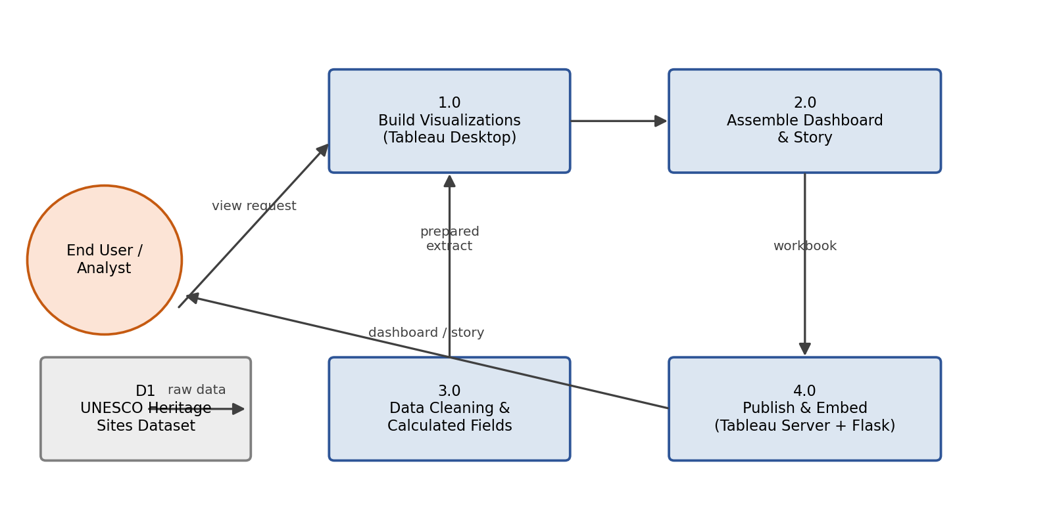
3.4 Technology Stack
Component | Technology
User Interface | HTML, CSS, Bootstrap, Flask (Jinja templates)
Application Logic | Python (Flask) for routing; Python (Pandas) for data cleaning
Visualization Engine | Tableau Desktop – calculated fields, dashboard, story
Data Source | CSV / Excel – UNESCO World Heritage Sites (2019) dataset
Hosting / Publishing | Tableau Server / Tableau Public
Deployment | Flask app deployed locally or on a cloud host (e.g. Render/Heroku)
4. Project Design
4.1 Problem – Solution Fit
Field | Details
Customer Segment(s) | Heritage conservation analysts, policy makers, tourism boards, researchers
Problem | Cannot quickly see site distribution, at-risk status, or regional trends
Existing Alternatives | Manually filtering the raw CSV in Excel or reading separate static reports
Solution | Interactive Tableau dashboard + story embedded in a Flask web app
Customer Constraints | Users may not know Tableau/SQL — interface must be self-explanatory
Channels of Behaviour | Published Tableau Server/Public link embedded on a web page
4.2 Proposed Solution
Parameter | Description
Problem Statement | Stakeholders cannot easily see site distribution, danger status or regional trends
Idea / Solution | Treemap + danger pie chart + regional trend line in one dashboard and story
Novelty | Combines distribution, risk and trend views in one filterable dashboard with a narrated story
Social Impact | Helps prioritize conservation funding and highlights strong-performing regions
Business Model | Public-interest/educational tool; extensible into a licensed reporting service
Scalability | Calculated fields and filters allow future data updates without redesign
4.3 Solution Architecture
The architecture spans a Data Layer (raw CSV), a Processing Layer (Python cleaning and Tableau Desktop authoring), and a Presentation Layer (Tableau Server/Public and the Flask web app that end users access).
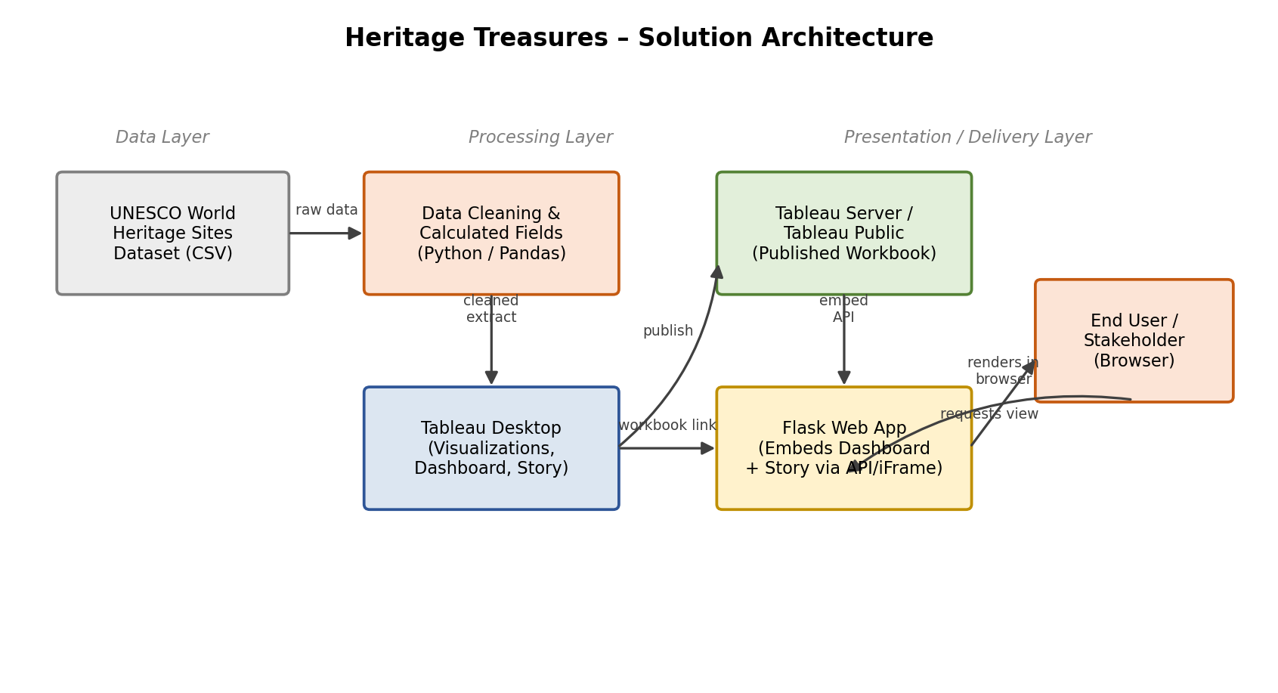
5. Project Planning & Scheduling
5.1 Project Planning
Sprint | Epic | Story Points | Duration
Sprint-1 | Data Collection & Extraction, Data Preparation | 12 | 6 Days
Sprint-2 | Data Visualization, Dashboard, Story | 20 | 6 Days
Total Story Points = 32 across 2 Sprints → Velocity = 32 / 2 = 16 Story Points per Sprint.
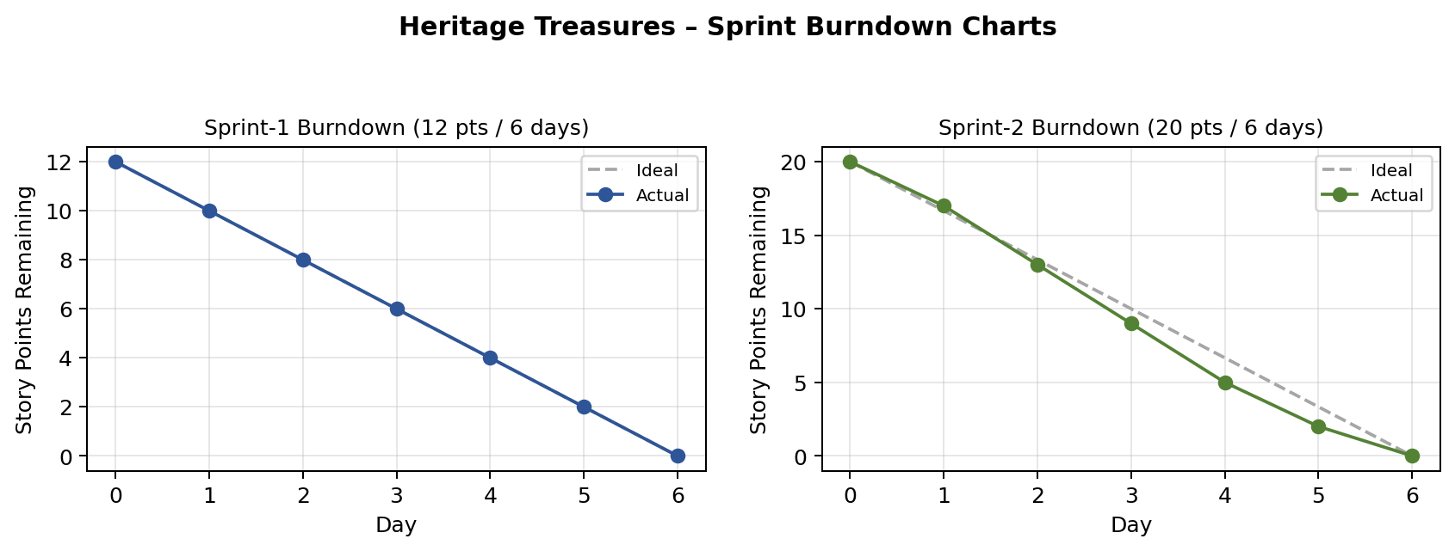
6. Functional and Performance Testing
6.1 Performance Testing
Parameter | Value
Data Rendered | 1,121 UNESCO World Heritage Site records
Data Preprocessing | Removed duplicates/nulls, standardized names, derived Danger flag
Utilization of Filters | 3 filters – Region, Category, Year range
Calculation Fields Used | 4 – Danger Flag, Years Since Inscription, Region Rank, Site Count
Dashboard Design | 3 visualizations combined into one responsive dashboard
Story Design | 3 story points reusing dashboard worksheets
User Acceptance Testing covered 6 test cases (chart accuracy, filter cross-interaction, story navigation, and the Flask embed) – all passed, with 2 minor low-severity issues logged (embed load-spinner delay, story caption overflow on small screens).
7. Results
7.1 Output Screenshots
The samples below are illustrative mockups showing the intended look of each visualization with representative sample data. Replace these with actual screenshots once the workbook is published to Tableau Server/Public.
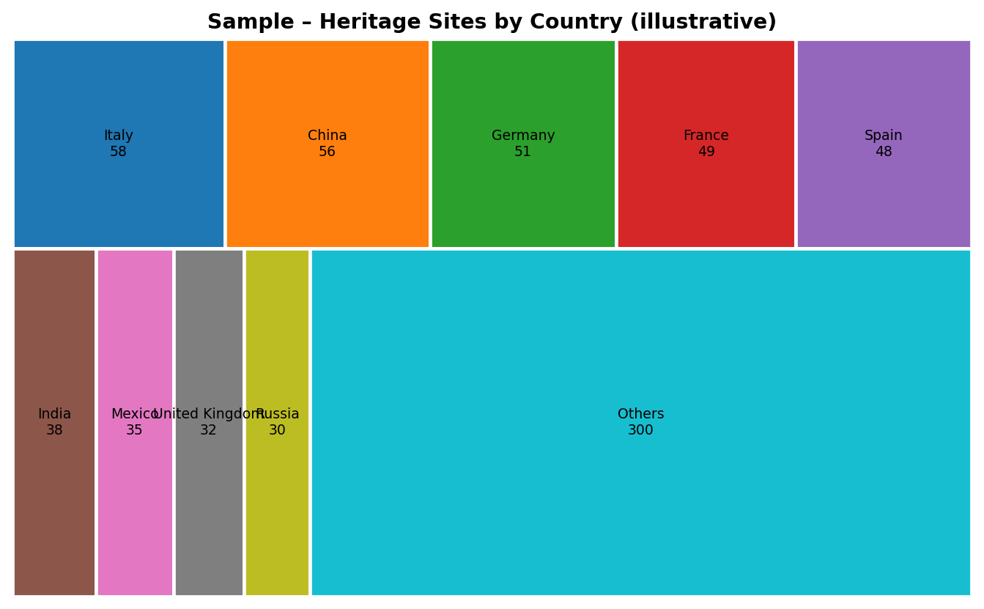
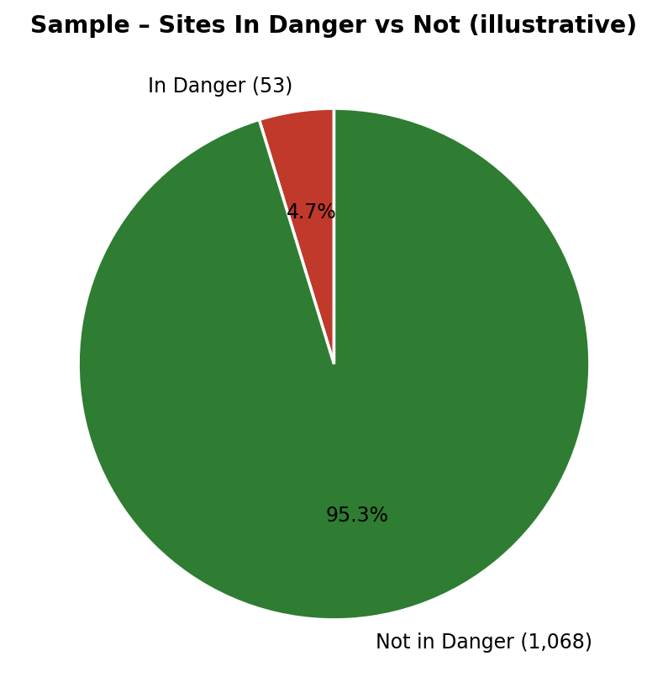
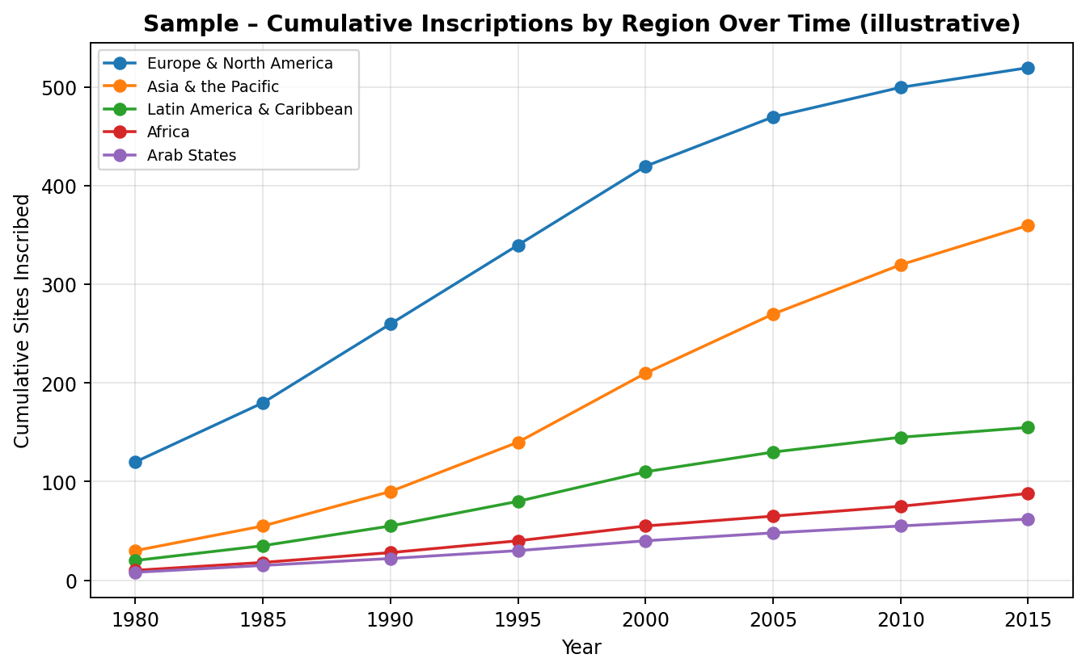
8. Advantages & Disadvantages
Advantages
- Consolidates distribution, risk status and time trends into one interactive view.
- No coding required for end users – filters and tooltips make it self-service.
- Tableau Public/Server hosting keeps infrastructure costs low.
- Story feature makes it easy to communicate insights to non-technical stakeholders.
Disadvantages
- Relies on a static dataset extract – no live/real-time data connection.
- Tableau Public dashboards can be slower to load on first visit.
- Requires Tableau licensing/publishing access for updates beyond the free tier.
- No built-in geographic map view in the current scope.
9. Conclusion
Heritage Treasures successfully turns a large, unstructured UNESCO heritage dataset into a clear, interactive Tableau dashboard and story. By combining a country-wise treemap, an at-risk sites pie chart, and a regional inscription trend line with cross-filtering, the project gives conservation analysts and policy makers a fast, visual way to identify priorities — fulfilling the goals set out in the Ideation and Requirement Analysis phases.
10. Future Scope
- Add a live/incremental data connection instead of a static extract.
- Include a geographic map view plotting sites by latitude/longitude.
- Add a simple '/api/summary' Flask endpoint for programmatic access to aggregate counts.
- Extend the dataset with visitor numbers or funding data for deeper impact analysis.
11. Appendix
Source Code
Source code (Flask app, data cleaning scripts, Tableau workbook) – add your repository path or attach as a separate archive.
Dataset Link
UNESCO World Heritage Sites (2019) dataset – add the exact source link used (e.g. the Kaggle or UNESCO Open Data link) here.
GitHub & Project Demo Link
GitHub Repository: [team lead to add link]
Live Demo: [team lead to add Tableau Public / Flask app link]

